Roasted Cauliflower Steaks with Fresh Gremolata

* [Nutrition](http://www.teambeachbody.com/teambeachbodyblog/category/nutrition)

* [Recipes](http://www.teambeachbody.com/teambeachbodyblog/category/nutrition/recipes)

April 13, 2015

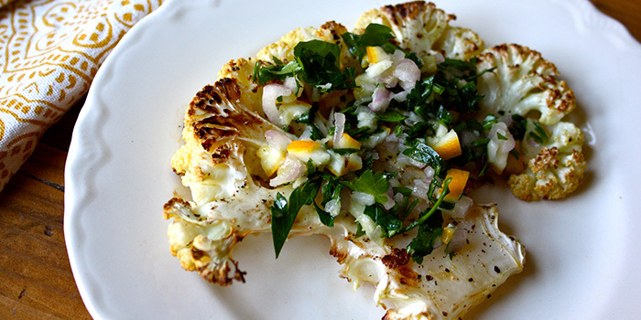

What is gremolata? Well, for starters, it might be your new favorite condiment. Gremolata is a classic Italian garnish made from ingredients you might already have in your kitchen: lemon, garlic, and parsley. On their own, they may seem ordinary, but chop them finely and mix them, and you have a zesty, herbal, garlicky topping. Ours has diced shallots for even more flavor. A spoonful or two on top of meats or vegetables gives foods bright, fresh flavor. Like these cauliflower steaks.

Roasting thick slices of cauliflower makes them taste sweet and hearty. Choose a nice, large head of cauliflower for the best results. If you can’t find a large enough cauliflower to cut into thick steaks like this, I recommend cutting it into florets and roasting as directed below. Keep an eye on cauliflower near the end of the cooking time to prevent burning. Brown, caramelized edges taste wonderful, but once they burn they will taste charred. I love this pairing with fresh gremolata, and I think you will too!

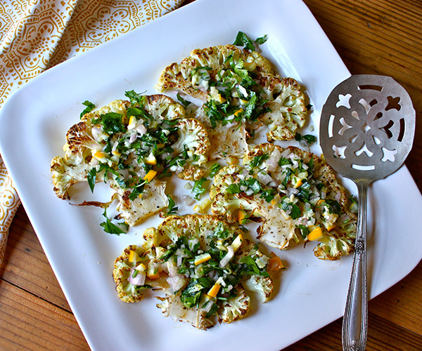

**Total Time:** 50 min.  
**Prep Time:** 15 min.  
**Cooking Time:** 35 min.  
**Yield:** 4 servings, 1 cauliflower steak each

**Ingredients:**  
1 large head of cauliflower  
4 tsp. olive oil, divided use  
½ tsp. sea salt (or Himalayan salt), divided use  
½ tsp. ground black pepper  
2 Meyer lemons (1 sliced into rounds, 1 finely chopped (including peel))  
¼ cup finely chopped fresh flat leaf (Italian) parsley  
1 medium shallot, finely chopped  
1 clove garlic, finely chopped

**Preparation:**  
1. Preheat the oven to 450° F.  
2. Trim 1-inch off end of cauliflower, leaving stem intact. Cut cauliflower into four ½-inch thick slices.  
3. Place cauliflower on a large baking sheet. Drizzle with 2 tsp. oil. Season with ¼ tsp. salt and ¼ tsp. pepper. Top with lemon slices.  
4. Bake for 20 minutes. Turn with a spatula. Bake for an additional 10 to 15 minutes, or u until cauliflower is tender-crisp and browned.  
5. While cauliflower is baking, combine remaining 2 tsp. oil, chopped lemon, parsley, shallot, garlic, remaining ¼ tsp. salt, and remaining ¼ tsp. pepper in a medium bowl; mix well.  
6. Top each cauliflower steak with 1 heaping tsp. of lemon mixture.  
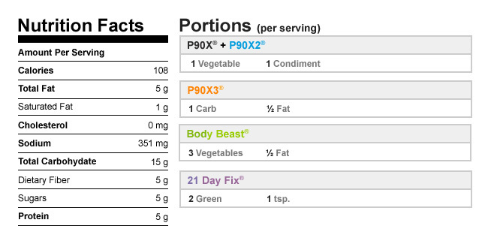

Authors

[Beachbody](http://www.teambeachbody.com/teambeachbodyblog/author/beachbody)

[Kirsten Morningstar](http://www.teambeachbody.com/teambeachbodyblog/author/kmorningstar)

Tags[dinners](http://www.teambeachbody.com/teambeachbodyblog/tag/dinners), [lunches](http://www.teambeachbody.com/teambeachbodyblog/tag/lunches), [recipes](http://www.teambeachbody.com/teambeachbodyblog/tag/recipe),[side dishes](http://www.teambeachbody.com/teambeachbodyblog/tag/side-dishes), [vegan](http://www.teambeachbody.com/teambeachbodyblog/tag/vegan),[vegetables](http://www.teambeachbody.com/teambeachbodyblog/tag/vegetables), [vegetarian](http://www.teambeachbody.com/teambeachbodyblog/tag/vegetarian)

RELATED POSTS